The Lies of Recycling

Nowadays, plastic recycling is recognised as a working, green and efficient solution to plastic pollution. This is the popular opinion, but once you look deeper into the history of plastic recycling, how it went mainstream, and the facts about plastic recycling’s true efficiency, you’ll see, just like I have, the misinformed popularisation of plastic recycling.

The first plastic waste recycling mill was created in Conshohocken, Pennsylvania in 1972, becoming the blueprint for all future recycling plants. This was an honest beginning for plastic recycling. After it’s first practices in 1972, plastic recycling would quickly go on to be recognized worldwide. Groups of environmentally aware people slowly started recycling their plastics whenever they could, but then big plastic companies came in.

More and more people started recycling, and in turn, started questioning the practises of plastic producers such as beverage bottle and plastic container producers. The big plastic producers didn’t like that. They had a problem: people weren’t comfortable with buying their products because the people were now more aware of plastic pollution, and how the plastic that these companies produce is non-recyclable.

What did the plastic companies do? The answer might seem unlikely. This:

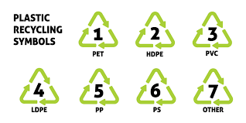

You probably recognise these signs. These are plastic recycling symbols. Look familiar?

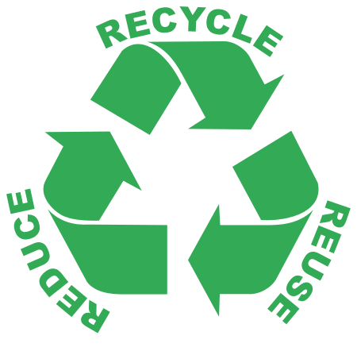

This is the Reuse, Reduce, Recycle symbol.

What I’m getting at might not be apparent, but let me explain.

People weren’t buying plastic products because they were feeling guilty for using something that will end up polluting the Earth. Some groups of people were making protests against these companies. This created a huge backlash for plastic. The big plastic companies saw this and created the plastic recycling symbols to classify different types of plastics but more notably, to give people the impression that their plastic products were recyclable by mimicking the RRR symbol. See, the plastic types present in the plastic recycling symbols are indeed recyclable, but they all have different recycling procedures, meaning they all need to undergo a different recycling process, otherwise, they will just end up as waste. Most of the “Recyclable” products needed to be recycled through treatment facilities that were very seldom found even in environmentally aware places at the time. Even when some people did know that their plastics needed to undergo different recycling procedures, they wouldn’t drive around the country to several different recycling facilities just to get rid of a week’s worth of plastic waste(understandably).

What the big plastics companies did might not seem very bad or dramatic, and it isn’t, it’s what the people did that made a huge difference for the worse. People started seeing the plastic recycling symbols on their everyday plastic products. This made them think that they can recycle all of their plastics, so they started pouring them into recycling plants, unaware that their plastics need to undergo separate recycling processes. People stopped feeling guilty about their plastics. This is all that the big plastics companies cared about. People were buying their products again.

The fact of the matter is, the problem of plastic has persisted for decades and people still rely on recycling to rid the world of plastic pollution. Less than 10% of plastics ever created were recycled, yet the public knows little about the true inefficiency of plastic recycling and how it will take more to tackle plastic pollution. We should be challenging people’s beliefs on recycling before it’s too late.